Lab 03
Implementation of a 8 bit Ring Counter


Spring 2025
CSE-308L
Digital System Design Lab

Submitted by: Naveed Ahmad
Registration No.: 22PWCSE2165
Class Section: B

Student Signature: ______________

Submitted to:
Engr. Shah Zada Fahim Jan
05 April 2025

Department of Computer Systems Engineering
University of Engineering and Technology, Peshawar

LAB 06:
Implementation of a 8 bit Ring Counter
OBJECTIVE:
- To become familiarized with behavior level modeling
- To be able to implement sequential circuits using Verilog
- To Implement an 8 Bit Ring Counter on Spartan 6 FPGA starter kit

Block Diagram:

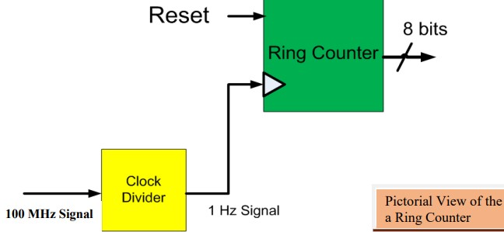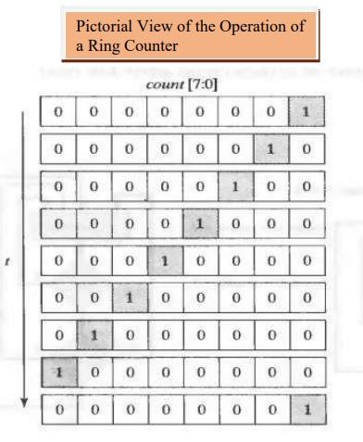

TASK 1:
Implement 4 bit Ring Counter

CODE:

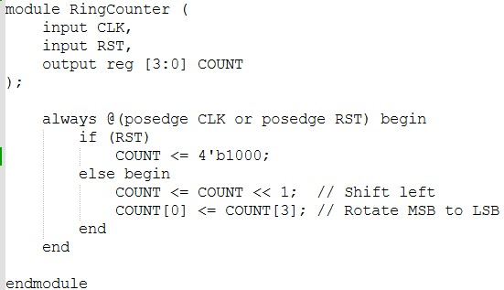

OUTPUT:
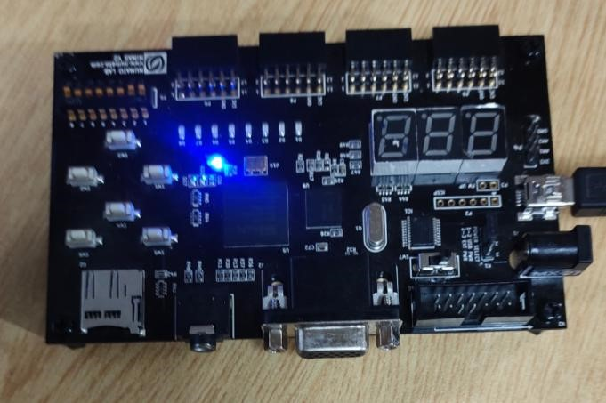

TASK 2: Implement 8-bit Ring Counter CODE:
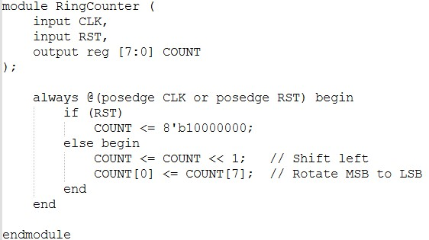

OUTPUT:

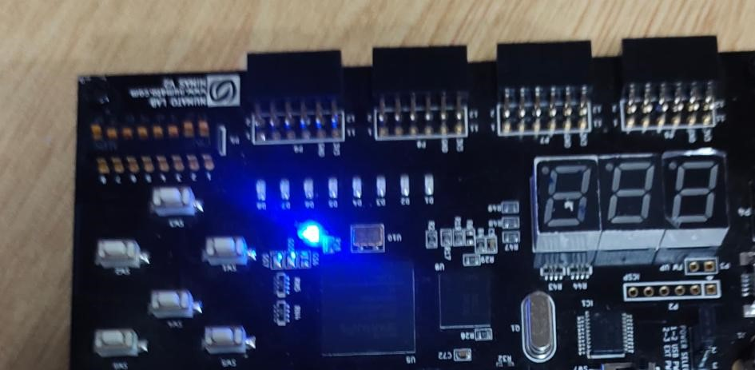

TASK 3:
For 4 bit Ring counter display the count in the seven segment display
CODE:
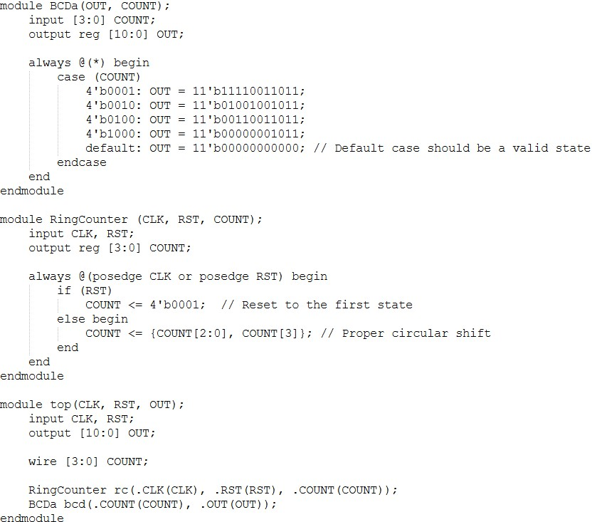

OUTPUT:
